<!--

Programmer: Kerwin Garcia

The purpose of this website is to calculate

monthly payment for a loan using javascript

-->

<html>

<head>

<title>Assignment 5</title>

<meta charset="UTF-8">

<meta name="viewport" content="width=device-width, initial-scale=1.0">

<script>

function computeLoan()

{

myLoan = parseFloat(document.loanForm.txtloan.value);

myRate = parseFloat(document.loanForm.rate.options[document.loanForm.rate.selectedIndex].value);

if (document.loanForm.term[0].checked)

{myYear=10;}

else if (document.loanForm.term[1].checked)

{myYear=15;}

else

{myYear=30;}

monthly=(myLoan\*(myRate/12))/(1-Math.pow(1+(myRate/12), -12\*myYear));

document.loanForm.txtpayment.value=monthly.toString();

}

</script>

</head>

<body>

<form name="loanForm" action="">

Monthly Payment Calculator:<br><br>

Enter Loan: <input type="text" name="txtloan" value="" /><br><br>

Select Interest Rate: <select name="rate">

<option value=".04">4%</option>

<option value=".45">45%</option>

<option value=".05">5%</option>

<option value=".055">5%</option>

<option value=".08">8%</option>

</select><br><br>

Select Term:<br>

<input type="radio" name="term" value="10" checked="checked" />10 Year<br>

<input type="radio" name="term" value="15" />15 Year<br>

<input type="radio" name="term" value="30" />30 Year<br><br>

Monthly Payment is: <input type="text" name="txtpayment" value="" /><br><br>

<input type="button" value="Compute Using Java Script" name="compute" onclick="computeLoan()"/>

</form>

</body>

</html>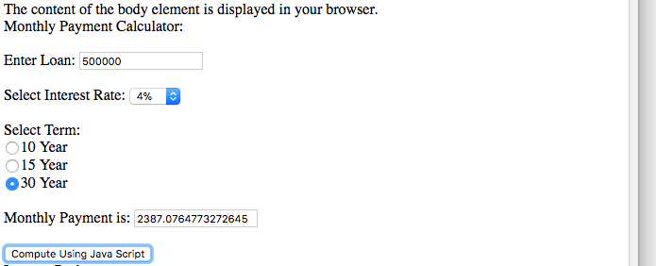

<!--

Programmer: Kerwin Garcia

ISYS 350

The purpose of this website is to calculate

cost of internet package cost by inputting

hours used using javascript

-->

<html>

<head>

<title>TODO supply a title</title>

<meta charset="UTF-8">

<meta name="viewport" content="width=device-width, initial-scale=1.0">

<script>

function computeP()

{

hours=parseFloat(document.getElementById("Hours").value);

if (document.getElementById("PA").checked)

{

if (hours <= 10)

{amount=9.95;}

else

{amount=9.95+3\*(hours-10);}

}

else if (document.getElementById("PB").checked)

{amount=14.95+2\*(hours-20);}

else if (document.getElementById("PC").checked)

{amount=20+1\*(hours-30);}

else

{amount=20+1\*(hours-30);}

if (document.getElementById("NP").checked)

{amount=amount\*(1-.20);}

document.getElementById("Due").value=amount.toString();

}

</script>

</head>

<body>

<form name="packages">

Internet Packages:<br><br>

<input type="radio" name="package" value="" id="PA" checked="checked" />Package A: 10 hours of access for $9.95 per month. Additional hours are $4.00 per hour.<br>

<input type="radio" name="package" value="" id="PB"/>Package B: 20 hours of access for $14.95 per month. Additional hours are $2.00 per hour.<br>

<input type="radio" name="package" value="" id="PC"/>Package C: 30 hours of access for $20 per month. Additional hours are $1.00 per hour.<br>

<input type="radio" name="package" value="" id="PD"/>Package D: Unlimited access for $29.95 per month.<br><br>

<input type="checkbox" name="nonprofit" id="NP" value="ON" />Nonprofit Organization<br><br>

Input Hours Used: <input type="text" name="hours" id="Hours" value="" /><br><br>

Amount Due: <input type="text" name="due" id="Due" readonly value="" /><br><br>

<input type="button" value="Calculate" name="calculate" onclick="computeP()" />

</form>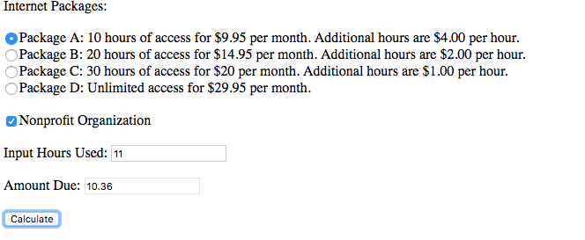

</body>

</html>

<!DOCTYPE html>

<html>

<body>

<p id="demo"></p>

<script>

var w = window.innerWidth

|| document.documentElement.clientWidth

|| document.body.clientWidth;

var h = window.innerHeight

|| document.documentElement.clientHeight

|| document.body.clientHeight;

var x = document.getElementById("demo");

x.innerHTML = "Browser inner window width: " + w + ", height: " + h + ".";

</script>

</body>

</html>

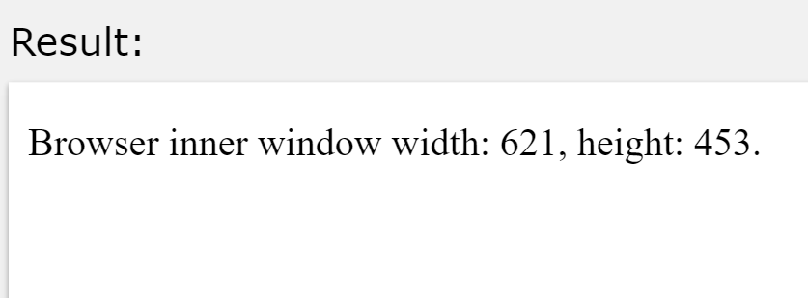

<!DOCTYPE html>

<html>

<body>

<p>Display the hostname (and the port if not 80) of the current URL.</p>

<p id="demo"></p>

<script>

document.getElementById("demo").innerHTML =

"Page hostname is: " + window.location.hostname;

</script>

</body>

</html>

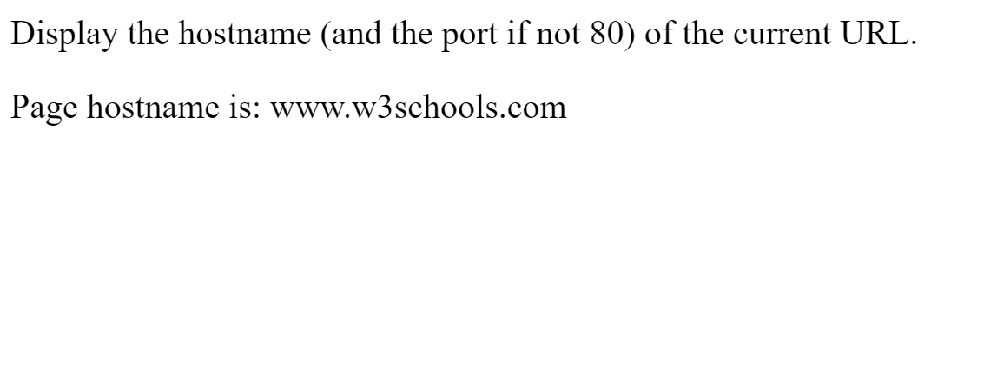

<!DOCTYPE html>

<html>

<body>

<p>Display the entire URL of the current page.</p>

<p id="demo"></p>

<script>

document.getElementById("demo").innerHTML =

"Page location is: " + window.location.href;

</script>

</body>

</html>

